# Run the model for screening pop

DS_screen =1 #Set whether the screening with dipstick happens, 0 - no, 1- yes

DS_age = 50 #Set the age of the dipstick if screening happens, set to zero if no screening

DS_round = 15 #' DS_round - number of the screening rounds

DS_freq =2

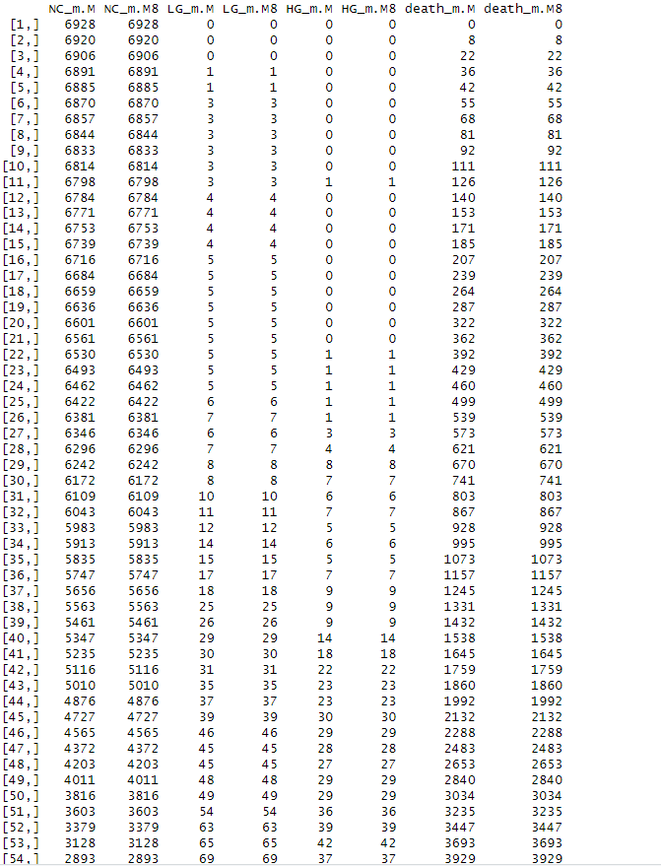

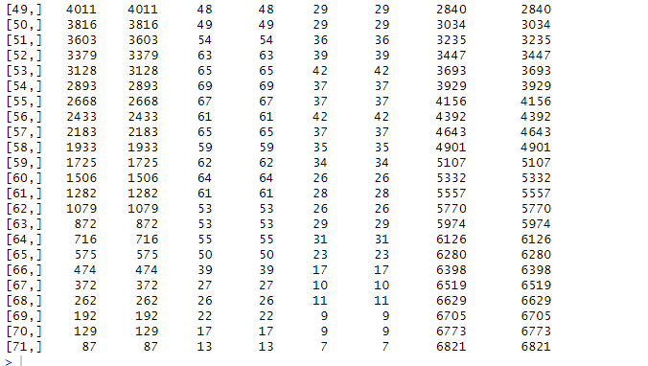

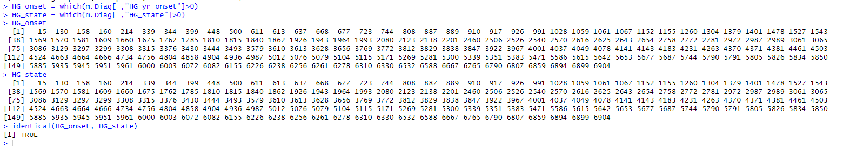

# check mort from BC is reflected

m.Diag =cbind(m.Diag,pop[ ,"PID"])

m.Diag_c = m.Diag[cancer_m.Diag, ]

p15_a=83

p214_a=67

p448_a=71

p500_a=93

p611_a=94

p668_a=84

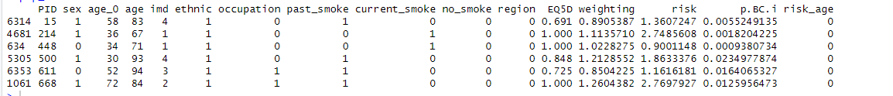

# Run the model for screening pop

DS_screen =1 #Set whether the screening with dipstick happens, 0 - no, 1- yes

DS_age = 50 #Set the age of the dipstick if screening happens, set to zero if no screening

DS_round = 15 #' DS_round - number of the screening rounds

DS_freq =1 #' D

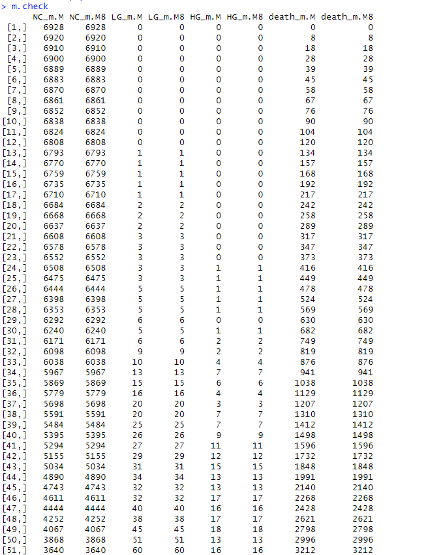

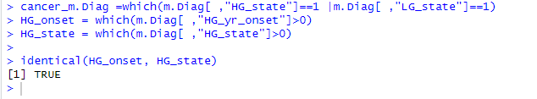

All-England pop (non cohort)

DS_screen =0 #Set whether the screening with dipstick happens, 0 - no, 1- yes

DS_age = 100

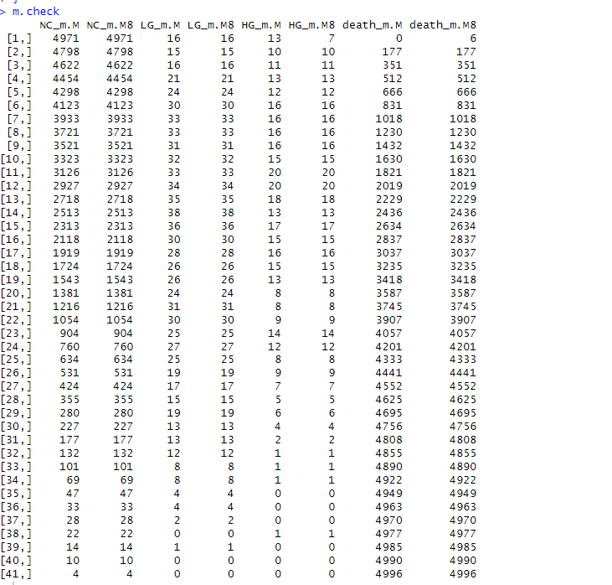

# Run the model for screening pop

DS_screen =1 #Set whether the screening with dipstick happens, 0 - no, 1- yes

DS_age = 50 #Set the age of the dipstick if screening happens, set to zero if no screening

DS_round = 15 #' DS_round - number of the screening rounds

DS_freq =1 #' DS_freq - frequency of the screening rounds (either 1 (annual) or 2 (biennial))

#iter=1

